SMT PROGRAMMING

OVERVIEW

GC Powerplace: Inputs (Gerber files, BOM) - Outputs (.pp file which contains X, Y, Ref Des, P/N)

- Import Gerber files into GC Powerplace.
- Find centroids, assign reference designators, and import BOM.
- Export component placement list.

Universal DPO: Inputs (.pp file) - Outputs (SMT Program - .c3x file)

- Import cad data (.pp file produced by GC Powerplace).
- Create board, in the board editor.
- Add non-existing parts to the parts database.
- Correct all polarities, assign feeders.
- Export component placement list.
- Save .c3x file to floppy.

GC Powerplace
Tech Support – 360-282-4888 support@graphicode.com

Use the same method for both top and bottom sides. Do the bottom side the same as the top, just pretend like there are 2 top sides. Use separate files for both, do not combine the Top and Bottom side together. You should have two .gwk files saved with a T and B on the end of the job number (i.e. 6753T and 6753B).

- Import Gerber files into GC Powerplace. File>Import
- Make sure all layers are in edit mode (e). If they are not right click on the layer and select Edit.
- Now select all pads and silkscreen characters. Edit>Select All
- Convert all sketched pads. CAM>Auto Convert Sketched Pads>Select Top Solder Paste>Select OK
- Set the silk layer to view mode (v) and paste layer to edit mode (e). Right click on the layer and select the appropriate mode.
- Select all of the pads and fiducials. If there are multiple boards/panel select the lower left board only.
- Find the part centroids. Parts> Automatic Centroid Extraction> Select OK> Select OK
- Left click on the layer tree and a new layer should appear. This new layer should be called P1 Parts “ACE Top Parts” top.
- Set the paste layer to hide mode (h). Right click on the layer and select hide.
- Expand the newly added parts layer. P1.1 are the parts which were recognized by the software and P1.2 are the parts which were not recognized and need to be taught.
- First hide the P1.2 layer and review all parts recognized in the P1.1 layer. Make sure the software correctly identified the part layout and package type. If it is not correct, select the part and explode the part. Parts> Explode Parts. This will send the pads back to layer P1.2.
- Hide Layer P1.1 and set layer P1.2 to edit mode. Select each pad that will make the individual part and then teach the part. Parts>Teach Part> Enter the package name> Click on Scan this layer for other parts> Click OK. This will teach the part and move it to layer P1.1.
- Continue teaching the parts until they are all complete. Also teach each fiducial separately.
- Hide all layers except for layer P1.1 which should be in edit mode. Now the reference designators need to be assigned. This can be done two different ways but I recommend option A.
- Manually enter in the reference designators Tools> Query.
- You can scan the silkscreen and let the software identify the reference designators. Parts>Find Reference Designators. This does not do a good job and makes many mistakes such as confusing 4’s and 7’s, 1’s and L’s. It will also assign the wrong reference designator to the wrong part if the board is heavily populated. Most of the time you spend more time correcting the mistakes than doing option A.
- Set the silk layer to view and P1.1 layer to edit. After all reference designators have been assigned. We can now import the BOM, but first we have to put it in the right format. Start with the BOM for assembly in the purchasing folder. Modify the BOM so every reference designator has its own line with the correct part number. All information except for the reference designator and part number can be deleted. Save the modified BOM as a tab separated .prn extension. See below for the format.

MFG Part Number | Location/Ref Des.
LM741 | U1
ERJ-8ENF1002V | R1
ERJ-8ENF1002V | R2
ERJ-8ENF1002V | R3
ERJ-8ENF1002V | R4

- Now import the BOM. Parts>Import BOM Information> Select the .prn file>Highlight the desired fields you want to import by using the start position and field length. The part number can only have a field length of 15 characters.>Scan>Import.
- All part numbers should now be imported and the CAD data is complete. Go to Tools>Query and compare every placement to the BOM for assembly. If everything matches go to File>Export> Component Placement List.
For Juki Machine

- (Job Number). PP file save as (Job Number).txt. Sequence is file, location, x-y co-ordinates, rotation, and part number.
- Take board dimensions from Gerber Files.
- Create Program from Program editor Janets.
- Name with Job number in PWB ID. Ex: Top or bottom follows with (Job Number) T.
- Add PWB Dimensions and Fid marks.
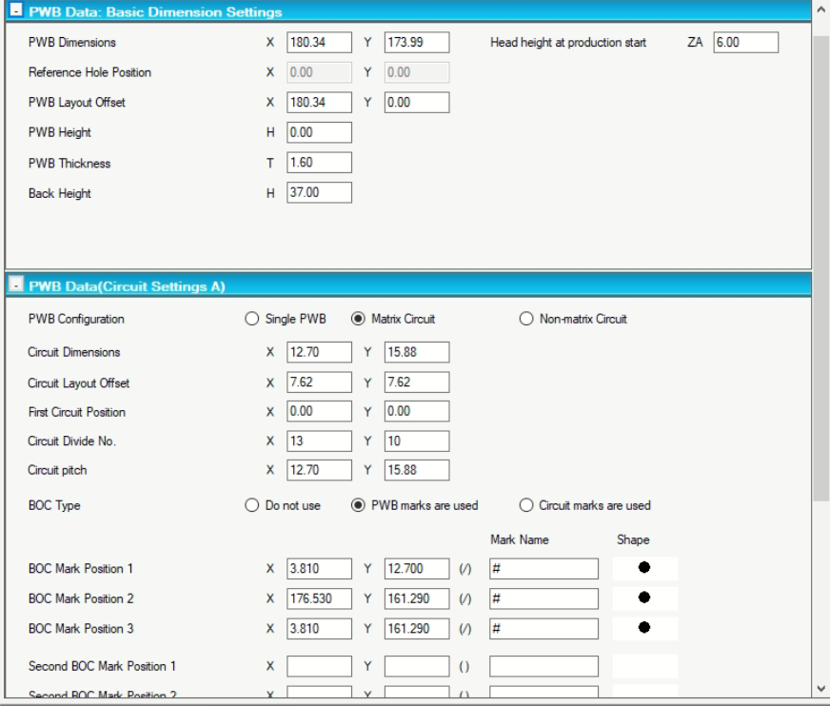
- Go to Placement data on right side and paste data from .txt file.
- Go to Component Data and identify each part from datasheet.
- Check all parts polarity.
- Check Data Completion Status in View menu.
- From optimize menu, optimize the program.
- Save the data and check the Status in View menu.

Special Cases: -
For Stick Feeder, check box ‘Assign several components to each stick feeder’ in when optimizing.

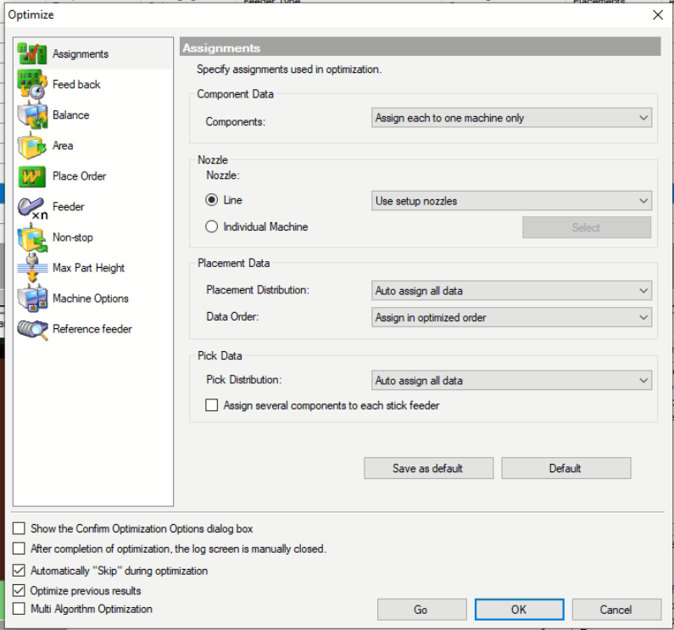

For GSM Machine
Universal DPO
Support – Ed Vargo (Universal Instruments) 919-868-9034 vargo@uic.com

- Open the DPO tool bar, click on the Enhanced CAD Import icon at the top.
- Go to File>Open File>Open File for Text Import> Select the .pp file produced in GC Powerplace.
- Go to File> New Product> Either select an existing board layout or select “create” for a new product.
- A new board file will pop up> Select Figure> Define Rectangle>Enter the Panel Dimensions. If there are multiple boards/panel go to Insert>Circuit. Then go to Figure>Define Rectangle>Give the board dimensions. Now we need to move .Figure>Add Array or Multiple Offsets. Save the board layout.
- Go back to the New Product box and browse to find the newly created board.>Select OK. The Product Graphic will pop up and you can just close it.
- Now go to File>Import. The parts which already exist in the database will be listed in the placements column. The parts which need to be added to the database will be listed under the invalid column.
- The parts in the invalid column will need to be added to the component database. You can select similar parts from the drop down menu in the bottom right. Once you have found a similar part double click the part in the invalid column to finalize the copy to the parts database.
- If you do not see a similar part in the database you can go to the parts database (GSM database editor) and create your own. Copy an existing part and modify the dimensions to match the component drawing.
- After all components have been moved from the invalid column to the placement column. Click Make Fiducial at the bottom of the screen and then double click the FID in the invalid column. Click update to finish. Go to File>Save Product As to save a copy.
- Close all screens.
- Go back to the tool bar and open the Advanced Product Editor icon, third icon from the top. Open the newly imported job File>Open.
- Open both the board graphic and placement list. Correct the polarities of each component to match the board layout.
- Open the feeder list. Window>feeder list. Assign every feeder a slot # and look at the feeder graphic to determine the open slots. Larger feeders require more slots. The 8 & 12 mm feeders use 1 slot and everything else uses 2-4 slots. The available slots you can use are 1-16, 21-36, 44-51, and 58-72.
- If there are too many parts and they will not all fit on the machine use steps below and skip 15 and 16.
- Export component placement list. File>Export>Export Comprehensive>Save as a .C3X format.
- Save the file to the job folder and to a floppy disk.

Too many parts to fit on one machine
- Save the current job as two different file names with a –M1 and –M2 as a suffix. This denotes machine 1 and machine 2. (example 7094-M1 and 7094-M2).
- Open the machine 1 program (-M1) and just export the component placement list without assigning feeders. File>Export>Export Comprehensive>Save as a .C3X format. That completes the program for machine 1.
- Now open the machine 2 program (-M2) and we will have to remove components from the placement list until there is enough room on the machine for all components to fit. We want to remove the most used resistors and caps because they will be placed with machine 1. Go to the component placement list and highlight the unwanted parts, right click and cut them. That will erase them from the program. After enough parts have been deleted, the remaining parts need to have the feeder assigned. Follow step #13, 15, and 16 to complete the program for machine 2.

Kic Profiler
KIC Tech Support – 858-673-6050
Sales – Robbie Smith (Circuit Technology) 704-458-0025 robbie@circuittechnology.com

- Open KIC software on laptop.
- Select Run a Profile; this is the top right icon.
- Click into the Product Name and type the job number.
- Enter the correct paste in the process window, either EP256 6337 for leaded paste or EM907 for the lead free.
- Leave the application on solder reflow and leave the sample rate at 4 readings/sec.
- Make sure the oven name is Omni 10 and click the forward arrow.
- Start the oven with an existing job. Go to file> Save As >Enter the new job number.
- Enter the oven temperatures into the KIC software; also enter the conveyor speed into the software. Click the forward arrow.
- Attach the thermocouples to the board using the aluminum tape. One thermocouple needs to be treated as the “Air thermocouple” and needs to be mounted hanging off the front edge of the board by 1 inch. The others can be mounted where any critical parts will go. It is good practice to position 1 thermocouple near the center of the board or panel. Usually 2-3 additional thermocouples are needed across the entire panel.
- Click the next arrow and then select the thermocouple channels you will be using. The #1 channel is always the air thermocouple.
- Make sure to insert the USB key into the laptop.
- Connect the USB cable to the KIC profiler and laptop. Select the stop light to proceed.
- Send the Kic profiler through the oven.
- When it comes out of the oven, use the USB cable to connect the profiler to the laptop.
- The information will immediately download and you can see the results. If the PWI is greater than 100% then re-do the profiling using the predicted data i.e. conveyor speed and heater temperatures.

